Forged Bowls & Vessels

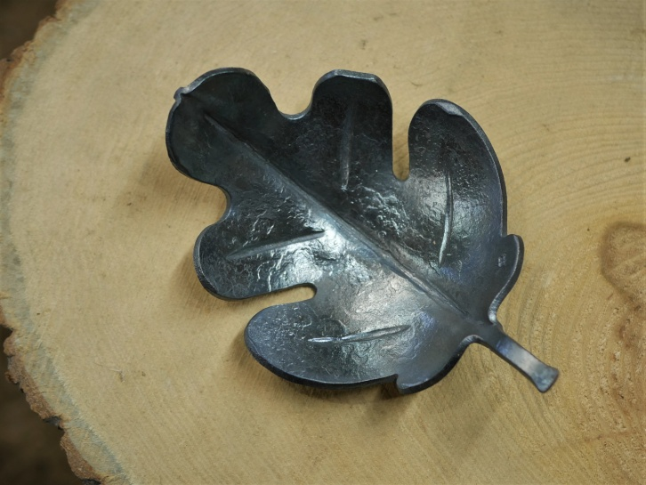

Date: **May 22-23, 2021**

Time: **9am – 5pm**

Cost: TBA

Location: Cook Cabin Heritage Center at 6707 Goshen Rd., Goshen Ohio 45122

Contact: Jamie Gier at [Jamie@evansfuneralhome.com](mailto:Jamie@evansfuneralhome.com)

Roy Adams of Christ Centered Ironworks will be guiding this weekend class in the exploration of steel bowl and vessel making. The focus will be on experimentation with texture, fold forming, and patterns. No previous blacksmithing experience is required.

