Christmas Gifts   
from the Forge

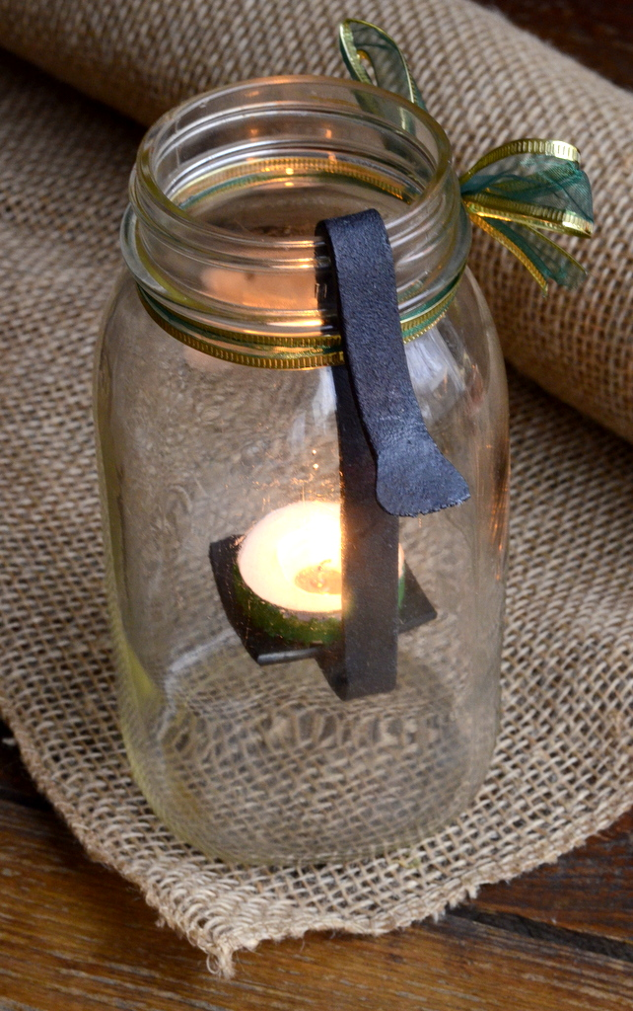

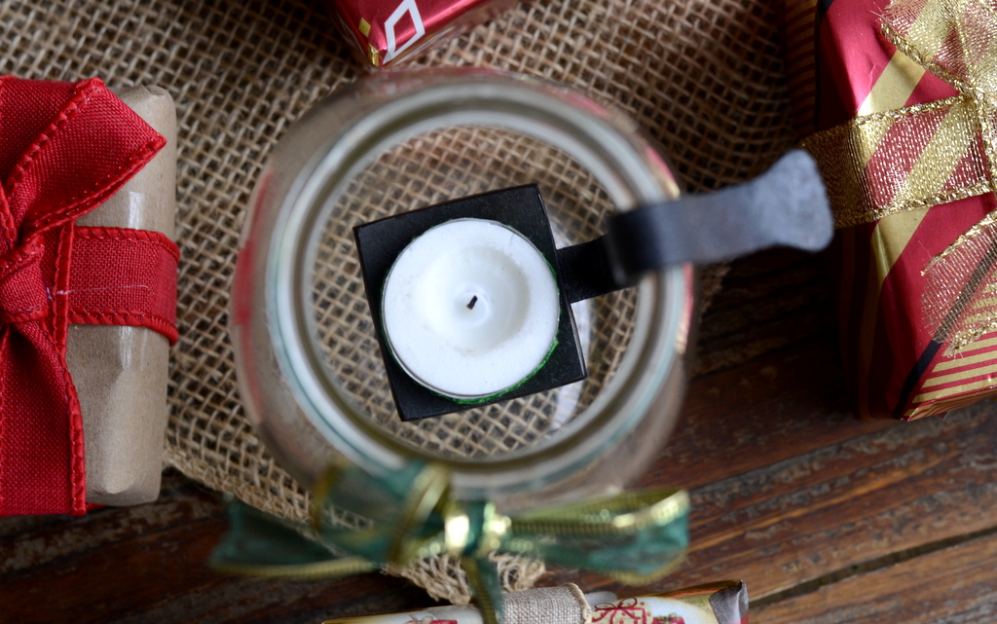

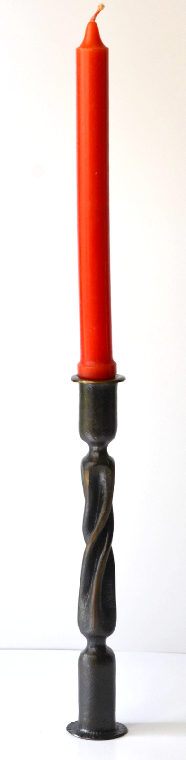

Date: **November 27-28, 2021**

Time: **9am – 5pm**

Cost: TBA

Location: Cook Cabin Heritage Center at 6707 Goshen Rd., Goshen Ohio 45122

Contact: Jamie Gier at Jamie@evansfuneralhome.com

Roy Adams of Christ Centered Ironworks will be teaching this class on making Christmas gifts with a focus on luminaries. He will demonstrate several different types of forged candles holders. Additional Christmas projects will be available as time allows.